SIMATS ENGINEERING
ASSESSMENT TOOL 2

COURSE NAME: Database Management Systems
COURSE CODE: CSA05

COURSE OUTCOME COVERED

CO1: Analyze DBMS architecture, different data models, schema types, and design ER/EER diagrams, relational schemas for case-based scenarios by identifying entities and relationships. (BL1, BL2)

Activity Tool : Concept Mapping (Medium)
Assessment Tool Weightage: 35%

QUESTIONS Total Marks: 50
Q.No | Question | Bloom's Level | Marks
1 | Construct a concept map linking the following terms: DBMS, Schema, Instance, Data Model, ER Diagram, Entity, Attribute, Relationship. | BL2 – Understand | 5
2 | Create a concept map for the three-level ANSI/SPARC architecture showing data independence at each level. | BL2 – Understand | 5
3 | Map the relationship between file-based systems and database systems, highlighting the problems solved by DBMS. | BL2 – Understand | 5
4 | Design a concept map for ER diagram components: entity, weak entity, attribute types, relationship types, and participation constraints. | BL2 – Understand | 5
5 | Construct a concept map comparing Hierarchical, Network, and Relational data models with their key properties. | BL2 – Understand | 5
6 | Develop a concept map for the EER model showing how it extends the basic ER model with generalization, specialization, and aggregation. | BL2 – Understand | 5
7 | Create a visual concept map for the DBMS software architecture, illustrating the flow from user request to data retrieval. | BL2 – Understand | 5
8 | Map the data models discussed in CO1 to real-world applications and explain the suitability of each model. | BL2 – Understand | 5
9 | Construct a concept map for schemas and instances, showing how they relate to physical and logical data independence. | BL2 – Understand | 5
10 | Design a concept map for the roles and responsibilities in a DBMS environment: DBA, End User, Application Developer. | BL1 – Remember | 5

Code of Conduct:

I MONISHA D/192311412 certify that this submission is my original work and that I have adhered to the guidelines specified for this assessment.
I understand that any violation of academic integrity rules will result in disciplinary action.

Signature of the student:
Monisha D

RUBRICS FOR CALCULATION:

Criteria | Weightage | Level 4 (Exemplary) | Level 3 (Proficient) | Level 2 (Developing) | Level 1 (Beginning)
Concept Identification | 25% | Identifies all key concepts from literature accurately and comprehensively | Identifies most key concepts with minor omissions | Identifies limited concepts; some are irrelevant or missing | Fails to identify essential concepts
Linkages | 25% | Establishes clear, meaningful, and accurate relationships between concepts | Shows correct relationships with minor gaps | Relationships are weak, unclear, or partially incorrect | No meaningful relationships established
Organization | 20% | Concepts are well-structured hierarchically with logical flow and grouping | Mostly organized with minor structural issues | Some organization but lacks clear hierarchy | No logical organization or structure
Integration of Literature | 20% | Integrates multiple studies effectively to show connections and comparisons | Shows some integration of literature | Limited integration; mostly isolated concepts | No integration of literature evidence
Clarity | 10% | Concept map is clear, neat, visually structured, and easy to interpret | Generally clear with minor readability issues | Clarity is reduced; difficult to interpret in parts | Poorly presented and hard to understand

1.Concept Map
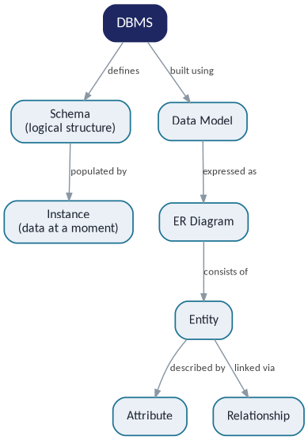

Explanation: A DBMS is defined by its schema, which is the overall logical structure of the database, while an instance is the actual data stored at a given moment — the schema stays fairly constant, but the instance changes every time data is inserted, updated, or deleted. The schema itself is built using a data model, which is expressed visually through an ER diagram. Each ER diagram is made up of entities, and every entity is described by its attributes and connected to other entities through relationships.

2. Concept Map
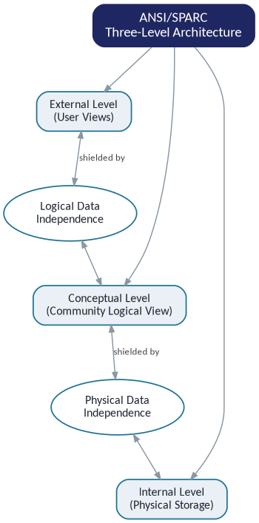

Explanation: The ANSI/SPARC architecture splits a database into three levels. The external level holds the individual views different users see, the conceptual level holds the single community view of the whole database, and the internal level deals with how data is physically stored. Logical data independence sits between the external and conceptual levels — it lets the conceptual schema change without breaking user views. Physical data independence sits between the conceptual and internal levels — it lets the storage details change without affecting the conceptual schema.

3.Concept Map
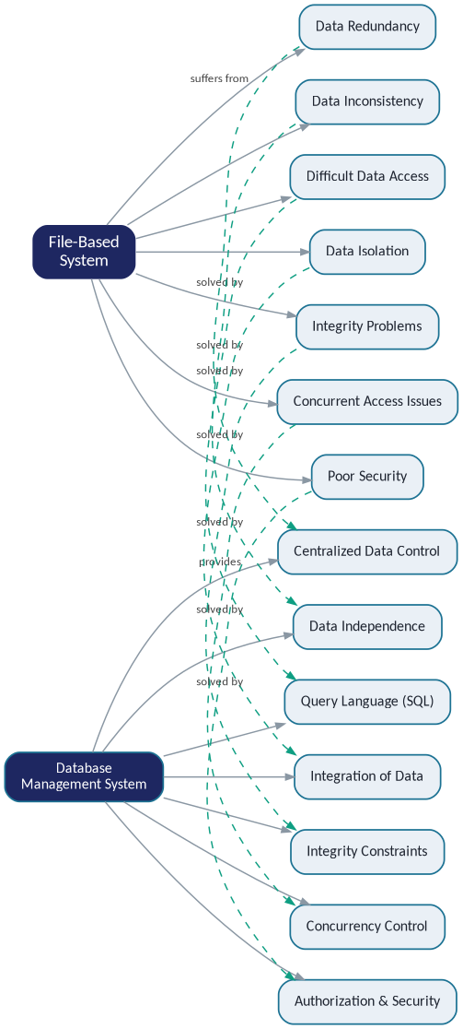

Explanation: File-based systems run into a predictable set of problems: the same data gets duplicated across files (redundancy), copies drift out of sync (inconsistency), data gets locked into one program's format (isolation), and there's no easy way to enforce rules, control concurrent access, or secure the data. A DBMS was built specifically to answer each of these: centralized control removes redundancy, data independence and SQL make access flexible, concurrency control and integrity constraints keep data safe and consistent, and built-in authorization handles security.
4.Concept Map

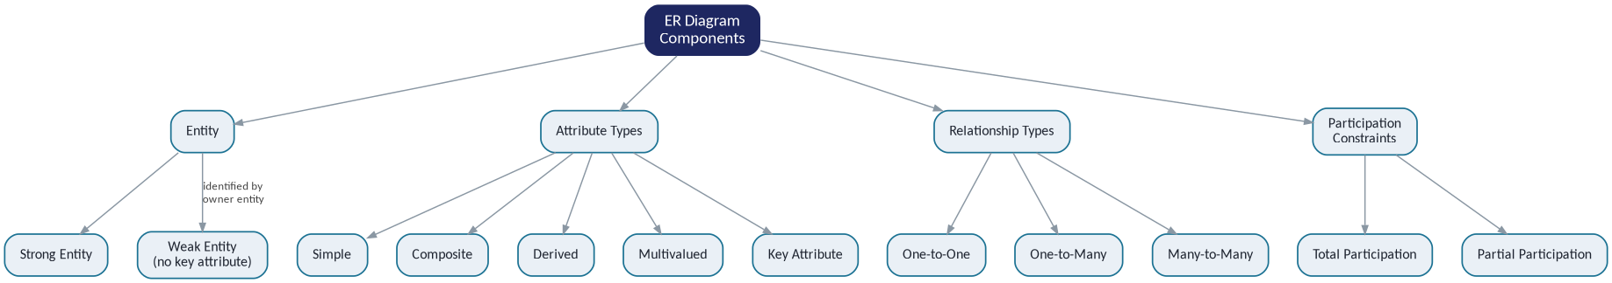

Explanation: An entity can be strong (has its own key attribute) or weak (depends on an owner entity for identification). Attributes come in several flavors — simple, composite, derived, multivalued, and key attributes. Relationships describe how entities connect, classified by cardinality as one-to-one, one-to-many, or many-to-many. Participation constraints describe whether every instance of an entity must take part in a relationship (total participation) or only some do (partial participation).

5.Concept Map

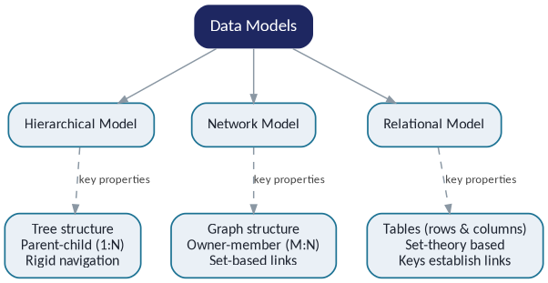

Explanation: The hierarchical model organizes data as a tree with strict parent-child (one-to-many) links, which makes it fast but rigid to navigate. The network model generalizes this into a graph, using owner-member sets so a record can have multiple parents, supporting many-to-many relationships. The relational model, in contrast, is based on set theory — data lives in tables of rows and columns, and relationships are established through keys rather than physical pointers, which is what makes it flexible enough to dominate modern databases.

6.Concept Map

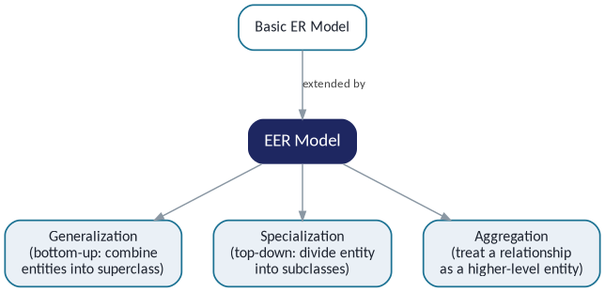

Explanation: The Enhanced ER (EER) model takes the basic ER model and adds three extra tools for modeling complex requirements. Generalization works bottom-up, combining several similar entities into one general superclass. Specialization works top-down, splitting one entity into more specific subclasses. Aggregation lets a whole relationship be treated as a higher-level entity, so it can itself take part in further relationships.

7.Concept Map
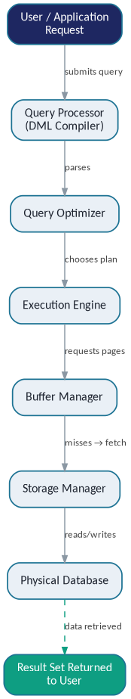
Explanation: When a user or application submits a query, it first goes to the query processor, which parses it, then to the query optimizer, which chooses the most efficient execution plan. The execution engine carries out that plan by requesting data pages from the buffer manager; if a page isn't already cached, the buffer manager asks the storage manager to fetch it from the physical database on disk. Once the required data is located, it is retrieved and passed back up the chain as the result set returned to the user.

8.Concept Map

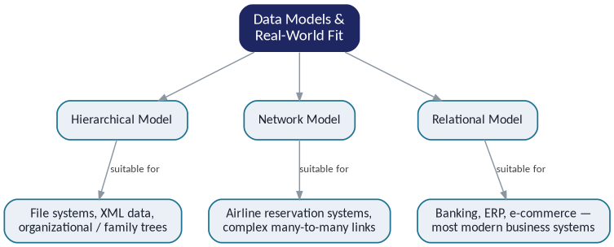

Explanation: The hierarchical model's rigid tree structure fits naturally with file systems, XML documents, and organizational charts, where there is always exactly one parent. The network model's ability to represent many-to-many links made it a good historical fit for something like airline reservation systems, where a flight connects to many passengers and vice versa. The relational model's flexibility and strong query support are why it is the default choice for banking, ERP, and e-commerce systems today.

9.Concept Map
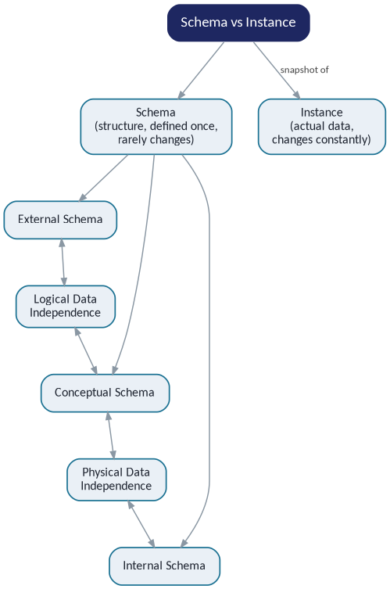

Explanation: A schema is the database's structural blueprint, defined once and rarely changed, while an instance is a snapshot of the actual data, which changes constantly. The schema itself is split into external, conceptual, and internal schemas. Logical data independence is the property that lets the conceptual schema change without forcing changes to the external schemas above it, and physical data independence lets the internal schema change without forcing changes to the conceptual schema.

.
10.Concept Map

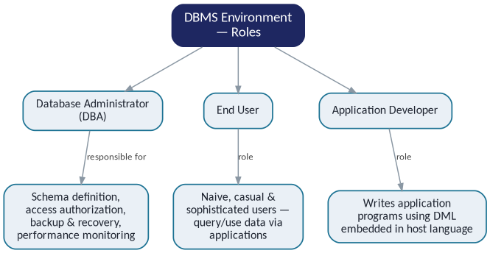

Explanation: The Database Administrator (DBA) owns the big-picture responsibilities — defining the schema, granting access authorization, and handling backup, recovery, and performance tuning. End users — whether naive, casual, or sophisticated — are the people who ultimately query or use the data, typically through applications rather than raw queries. Application developers sit in between, writing the programs (using DML embedded in a host language) that let end users interact with the database without needing to know it directly.

